PROCEDURE FOR HIGH PRESSURE WATER JETTING -HPWJ

Distribution:

 | Prepared by: | Reviewed by: | Reviewed by: | Approved by: | Registered by:
Date & Sign:
Name(s): | Selva Subarayan | Alex Hadfield | Jacques Theron | Raed Al Ghamdi
Position | (HPWJ Section Head) | (PTD Manager) | (HSE Manager) | (Gen. Manager) | (QA Team Leader)

Table of Contents

1.0 OBJECTIVE 3

2.0 SCOPE 3

3.0 DEFINITIONS 5

4.0 SAFETY NOTICES 7

5.0 LEGAL REQUIREMENTS 11

6.0 DUTIES & RESPONSIBILITIES 11

7.0 TRAINING 12

8.0 PROCEDURE –AUTOMATED OPERATION 13
9.0 PROCEDURE- MANUAL OPERATION 15

10.0 JETTING IN CONFINED SPACE 18

11.0 EFFLUENT DISPOSAL 19

12.0 SUPPLEMENTAL PROCEDURE....................................................................................................................19

13.0 RELATED DOCUMENTS ................................................................................................................................. 19

14.0 ATTACHMENTS .................................................................................................................................................20

15.0 CHANGES FROM THE PRECEDING ISSUE .................................................................................................20

OBJECTIVE

The objective of this procedure is to ensure that all High Pressure Water Jetting activities are conducted in a safe operating practices and safeguard equipment users and consistent manner to achieve the desired results.

2.0 SCOPE

2.1 General
HPWJ Operations – Overview

- Evaluate: Assess alternative cleaning methods than HPWJ, If HPWJ selected then complete technical form.
- Plan: Arrange/ Plan for HPWJ work with approved methods
- HPWJ Preparation: Preparation includes equipment, personnel, PPE, Inspection training, transport.
- Review Risk (Risk Assessment): Prepare formal JSA/ RA and inspect equipment & prepare for HPWJ Set up at site.
- Site Preparation: Review Work Permit request and issue permit and set up required arrangements.
- Set up Site: HPWJ supervisor & Safety team agreed by HPWJ authorizing person and client.
- HPWJ Work Permit: Review field set up and fill up pre-job HPWJ checklist
- HPWJ Execution: Perform HPWJ Work complying to safe work practices & site instructions
- Remove Equipment, restore site: After completion of work remove equipment & restore site in safe condition

Prior to any HPWJ activities, an evaluation of the type of HPWJ process must be conducted.

It describes methods for eliminating or reducing hazards and risks associated with water jetting.

The following flow chart shall be followed for evaluating the Hydro jetting activity.

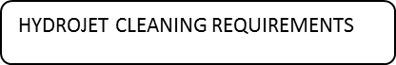



 | FULL AUTOMATIC MACHINE
RISK LEVEL -1 Green Zone |  |  |  |  | 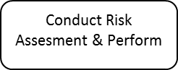
 |  | 
 | SEMI AUTOMATIC MACHINE
RISK LEVEL -2 Green Zone
 |  | 
RISK LEVEL- 3 |  |  |  | Prior Approval from the Management required before the manual cleaning to be performed.
Orange Zone | 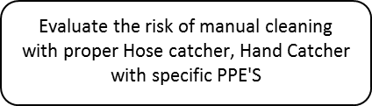
(Only Acceptable with Risk Assessment)
The scope of this procedure covers the safety, guidelines, definitions and working practices and general work methods for High Pressure Water jetting (HPWJ) activities for all types of operation, automatic, semi-automatic and manual.

- DEFINITIONS
3.1 Hydro jetting

Hydro jetting: (Water Jetting) The term Hydro jetting covers all water jetting process including those additives or abrasives, where there is energy input to increase the pressure applied to water.

It is the process to remove accumulated contamination and dirt buildup on surfaces as well as blockages on tubes or pipes using the high velocity water pressure through a jet nozzle.

    - In this procedure, the term Water Jetting will be taken to include all pressures up to 25000psi (1723 bar).
    - Equipment operating above this pressure is referred to as Ultra High Pressure (UHP).

3.2 Dump Valve

A manually operated 'fail safe valve' which requires a consistent pressure by the lance operator to activate the water stream. It will stop, divert or lower the pressure of the water stream if the handle is released.

3.3 Lancing

Lancing: Is an application whereby a rigid or flexible lance and nozzle combination is inserted into, and retracted from, the interior of a pipe or tube for cleaning purposes.

3.4 Moleing

Moleing: Is a Hydro jetting operation where a hose, lance and nozzle combination is inserted into, and retracted from, the interior of a pipe. It is commonly used for cleaning the internal surface of drains and pipes. Other common names: Rodding, drain cleaning.

3.5 Nozzle

Nozzle: It is a device with one or more orifices through which the water discharges from the system. The nozzle restricts the area of flow of the fluid, accelerating the water to the required velocity, (creating what is commonly referred to as “pressure”). Fig shown examples of Nozzles.

Common names: Tips, orifices, Jets.

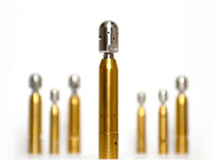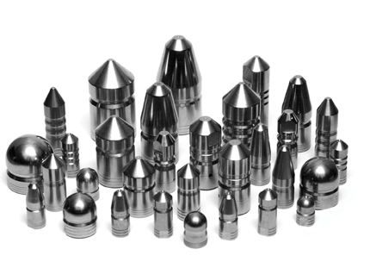

NOZZLES

3.6 Competence

Competence: A competent person is someone who has the sufficient training with experience or knowledge. The level of competence required will depend on the complexity of the situation and the particular task. They must be able to make informed decision and follow a Safe System of Work.

3.7 Shot Gunning

Shot gunning: Is a Hydro jetting operation where a High Pressure Gun/ Hand-lance and nozzle combination can be manually directed in virtually all planes of operations. The length of barrel must be 1.2 m from the rearmost trigger to end of the nozzle.

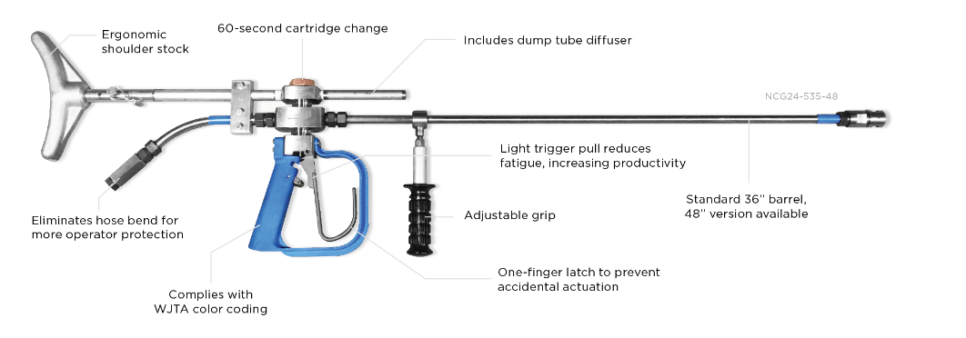

20,000 PSI Hand Gun

3.8 High Pressure Water Jetting (HPWJ)

Water jetting activities are defined in to three (3) areas;

- UHP (Ultra High Pressure) which operates at a maximum of 36,250 psi or 2500 bar
- HP (High Pressure) which operates from 3000 psi to maximum of 20,000 psi or 1,380 bar
- LP (Low pressure) which can be operated below 3,000 psi or 200 bar.
It is defined as pressured water cleaning of equipment above 250 bar (3625 psi).

The maximum allowable pressure for HPWJ activities is 2759 bar (40,000 psi).

No HPWJ should be conducted on equipment above this maximum allowable level.

3.9 Safety Chain/ Whip-check Cables

Whiplash cables are to be fitted to all end connections of the HP hoses, this is a specific piece of safety equipment designed to stop high pressure hoses that separate from whipping round and striking the operators.

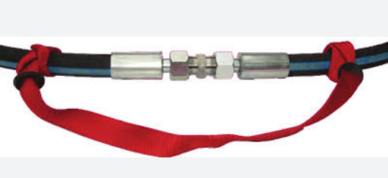

SAFETY NOTICES

4.1 Safety Requirements

- A valid permit to work is required to be issued by the client prior to any HPWJ activities.
- A valid Risk Assessment and Job Safety Analysis are required to be compiled, approved and fully understood by the Supervisory personnel and the HPWJ Operators.
- Where appropriate, it may be necessary to interpret and translate the requirement of the Risk Assessment and/or Job Safety Analysis.
- Barricades, signage and deflection boards barricades, appropriate signage and lighting must be in place prior to any HPWJ activities taking place.
- When required, boards must be positioned to prevent any loose ejected material/projectiles being shot from tube bundles. These boards should be placed at the opposite end of the HPWJ activity.
4.2 Personal Protective Equipment

To keep the risk of possible injuries during HPWJ as low as possible, the following PPE must be used

S no | Mandatory PPE during HPWJ
01 | Safety Helmet | 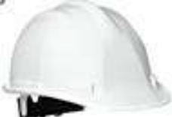 | Mandatory for All the Operations
02 | Hearing Protectors | 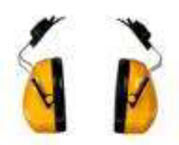 | Mandatory for All the Operations – Ear Muffs/ Ear Plugs or Double Hearing Protection
03 | Protective goggles |  | Mandatory for All the Operations
04 | Face- Protection visor | 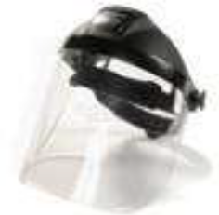 | Mandatory for All the Operations
05 | Hand Protection  EN-388 Std. | 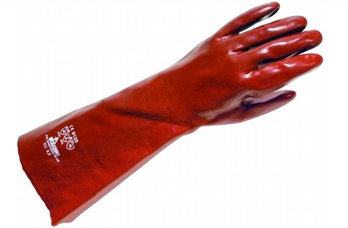 | Mandatory for All the Operations
06 | Water proof Splash Body Protection – Automatic & Semi-Automatic Operations | 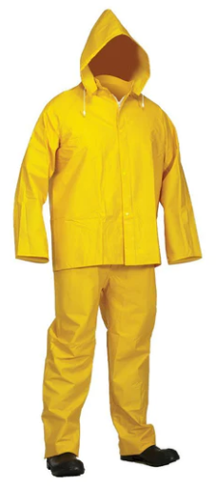. |  | Only for Automatic & Semi-Automatic Operations
05 | Heavy duty water proof protective suit/ TST Suit until 25,000 PSI | 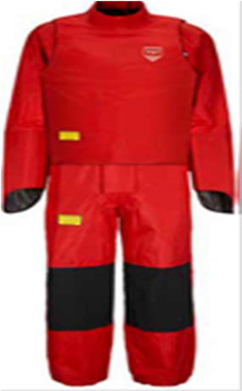. |  | For Any Manual Operations – Gun Operations & Manual Lancing
06 | Turtle Suit for 40,000 PSI | 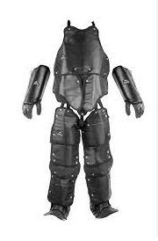 |  | For Ultra High Pressure Operations  More than 25Kpsi
07 | Rubber/Gum boots |  |  | For Automatic & Semi-Automatic Operations
07 | 360 Degree Gaiters | 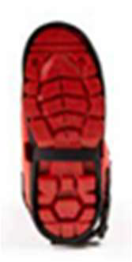 |  |  | For Manual Operation Up to 25,000 Psi
08 | Neck Protection | 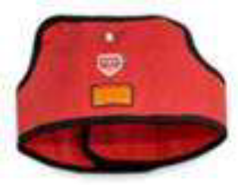 |  |  | For Manual Operation –Gun & Manual lance.

And any other PPE that may deem necessary as determined by the physical locality of the HPWJ, it is recommended to consult the SHE Department prior to execute these activities.

4.3 Do’s & Don’ts

DO’S | DONT’S
- Obtain work permit.  - Do proper risk assessment.  - Erect barriers, and place working signs.  - Ensure adequate water supply.  - Check machine, according to checklist.  - Lay out equipment and inspect for defects.  - Assemble equipment, and check all joints.  - Ensure that filters are clean.  - Prime equipment and flush when necessary.  - Fit gun & lance and check nozzle size and type  - Correct.  - Increase pressure slowly until work pressure is reached.  - Re check joints & couplings for leaks.  - Shut down machine release pressure and rectify leaks.  - Ensure correct PPE.  - Rotate certified team members.  - Regularly check operating conditions, oil, and temperatures.  - Release all pressure when shut down.  - Strip equipment, clean and replace in store.  - Clear all barriers, signs.  - Ensure all paper work has been completed.  - Ensure that all pressure in lines is released on any shut down.  - Upon completion, strip down equipment and store in clean condition.  - Clear the site of barriers, warning signs and debris, to customer’s satisfaction.  - Upon completion, ensure that customer has signed the necessary paperwork (satisfaction notes, work sheets, etc.). | - Commence work on site without necessary permission.  - Commence any jetting operation until warning signs are on show and area is roped off.  - Operate without adequate personal protection for eyes, head, ears hands, feet, and body.  - Run any equipment with leakage whatsoever, without rectifying.  - Attempt to tighten any pressure joint while equipment is under pressure.  - By –pass safety cut-outs.  - Operate with equipment not functioning correctly (leaking or failing to shut off).  - Operate guns or control valves with the operating lever tied back, wedged or locked in the ‘ON” position.  - Operate with badly worn or undersize nozzles.  - Continue to operate is any unauthorized personnel enter the operating area.  - Operate equipment at power levels which can produce a reaction force greater that the lance/ gun operator can comfortable absorb.  - Leave high pressure water jetting unit running unattended.  - Leave equipment unattended on site.  - Store unserviceable equipment (notify supervisor).  - Leave the site in a dangerous or untidy condition.  - Leave site without notifying all parties (engineers, site agents, occupiers, etc.).  - Take shortcuts  - Get Distracted  - Listen to advice from Co Workers always take Instruction from your immediate Supervisor.  - Use sub standard Equipment.  - Endanger the lives of your colleagues.

LEGAL REQUIREMENTS

Applicable legal regulation and requirements, latest revision as appropriate.

DUTIES & RESPONSIBILITIES

6.1 Project Manager/ Project in charge

- These individuals have the overall responsibility and authority to ensure that the HPWJ activities are conducted in a safe, timeous and consistent manner and strict adherence to the decision tree is followed.
- They are further tasked that the HPWJ Supervisors, Foremen & operators are aware of the safety requirements of the job to be conducted.
- The operators must be suitably trained, certified and fit to perform the HPWJ activities. This responsibility cannot be delegated.

6.2 Site Supervisor- HPWJ

- The site supervisor has the responsibility to ensure the basic equipment checks take place through a visual inspection using the water blast pre operations check list.
- Hoses cannot have broken or rusted steel braids
- Check O- Rings and gaskets must be properly installed and in good condition
- Check water filters
- Confirm Rupture discs are installed (Rated for no greater than 1.2 times. Maximum allowable working
pressure of lowest rated component in the system.
- Check dump valve or trigger must be installed and operating correctly.
- Check for Worn or plugged nozzles (tips)
- Hoses have been inspected for wear and damage.
- Fittings, barrels, lances and stingers must be rated for a working pressure at least equal to or greater than the maximum working pressure of the pump.

6.3 HSE Supervisor

They have the defined responsibility and authority to immediately stop any HPWJ activities that may be deemed to be dangerous or compromise the safety of the HPWJ operators; standby personnel or any persons within the vicinity of the HPWJ activities.

In addition, the HSE Supervisors can offer practical advice to ensure that these activities are carried out in a safe and practical manner.

6.4 HPWJ Team Members

For all the jetting operations, team shall consist of a minimum 03 members (HP Jetters)

- The number of operators will depend on the equipment being used and the nature of the job, but direct line of sight must be maintained between the machine operator and the water jetting operator.

- A team member is required to operate the EMERGENCY STOP and clear defined methods of communication must be established when the Water jetting operator is out of the line of sight of the machine operator.

- All team members be aware of all the safety requirements and be able to react to any situation. Do not compromise in safety of the HPWJ Operator & other team member as well.

- All jetting operations must be controlled by a suitably trained and competent person.

6.5 HP Jetter Operator

- These operators must be trained and have valid and current certification for the process to be used whilst using HP Water Jetting equipment and must work in accordance with the relevant safety best practices as well as adhere to the specific clients’ safety rules and regulations.

- Understand the hand signals and to have good coordination between the operator and crew.

6.6 Emergency Button Operator

- Must be in direct line of sight of the HPWJ operator as well as the pump operator, his only task is to react to any emergency situation which may arise and react immediately.

TRAINING

7.1 All HPWJ Team must have a valid and current training certification and qualification relevant to the type of HPWJ activities they are performing; the certification is to be issued by the Training Department and must be verified by the HPWJ Supervisor prior to any HPWJ activities being started.
7.2 Manual water jetting, if not handled competently is a potentially hazardous process, it is therefore important that each operator assigned to high-pressure water cleaning jobs shall be adequately trained in the safe operation of the equipment.
7.3 The following listed topics training provided by ANABEEB IN House training department.
- Cutting action of high-pressure water jet.
- Correct selection of nozzles and water pressure.
- Personnel protective equipment requirements.
- Inspecting Hydro jetting unit.
- 10K, 20K Basic operations, TLE/LTC & IBC, OBC, Bundle Blaster
- Purpose of primary equipment.
- System operation, including lance handling and emergency shutdown procedures and signals.
- Safety devices.
- Safety precautions.
- Description of water supply factors, electrical hazards, electrical grounding, and wastewater control.
- And any other training requirement deemed necessary based on the educational standard of the operators and / or the specific project requirements.

- All the HP hoses, Gun, flexible lances, Foot valves, Pressure relief valve to be pressure tested and maintain the record and submitted during Plant inspection.

- SEMI AUTOMATED & AUTOMATED LANCING

  - Automated cleaning tools such as Lance tube cleaner 2XL, 3XL, Inside Bundle Cleaner, Outside bundle cleaner, Rigid lancing machines/ Tank cleaning heads, 3D nozzles, gamma jets, rotary lances etc. should be employed to limit the personal exposure during HPWJ operations.

2 XLTC (Two lance tube Cleaner) 3 XLTC (Three lance tube Cleaner)

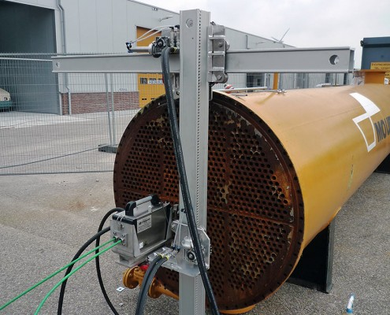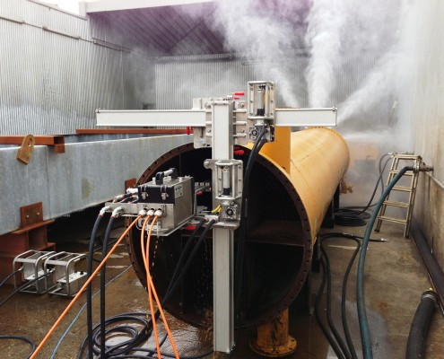

Rigid Lancing Machine
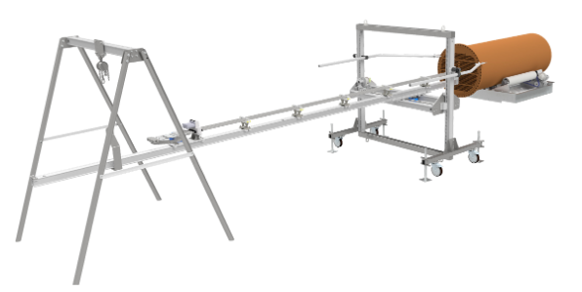

Inside Bundle Cleaner Outside Bundle Cleaner

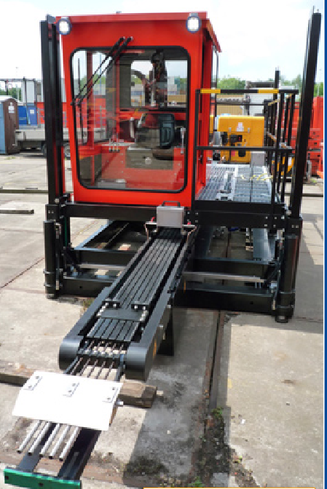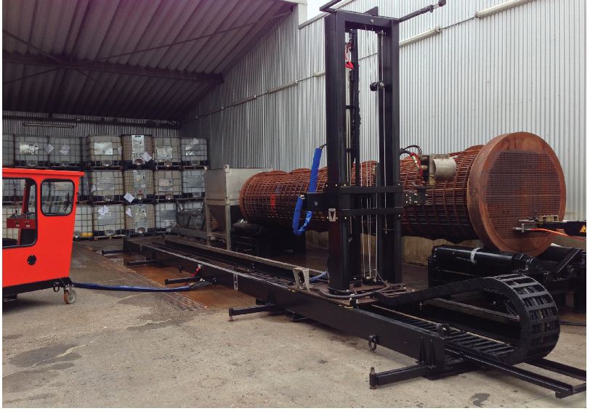
3D Nozzles (Tank Cleaning Nozzle)

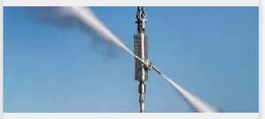
- Automated cleaning operations allow for long cleaning periods without exposing employees to the
Hazards of manual operated high pressure water jetting.

  - The advantage of using mechanized tools and nozzles is the increased level of safety and high
cleaning efficiency that they generally provide. Where workers can be removed from the manual
cleaning process, their exposure to water jets and hazardous material is significantly reduced and
the safety and productivity are improved.

  - Safety Controls: Flow Control (Diverter) Valve and Foot Pedal (Dump Valve)

  - All Automated system components will be set up as per the manufacturer’s recommendation.

- The operator controls the action of the systems from a remote position nearby.

PROCEDURE – MANUAL OPERATION

APPROVAL FROM MANAGEMENT IS REQUIRED BEFORE PROCEEDING MANUAL LANCING FOR HYDRO JETTING (GUN OPERATION/LANCING)
  - Qualified Operators: only personnel who have undergone a proper training program and who have demonstrated the knowledge and skill, and gained the experience to perform all the likely assigned tasks shall operate any high pressure water jet equipment.

  - Minimum 02 Years of experience (Continuous Operation) is required for HP Jetters who is authorized to do Manual Operation and it will be identified in the training card.

  - A minimum of 3 men should work as a unit with as few changes as possible in the personnel involved. One man will operate the lance, accessory, while the other monitors the engine, pump and maintains constant safety surveillance of the job area and one man should control the emergency shut off system.

  - The Hydro jetting equipment daily Safety Checklist should be completed; Before starting a job and at the beginning of each shift, check out the operation and condition of all equipment, including the water filter, pump, Engine, fuel, relief system, pressure gauge, HP hose, Control valve (fail safe valve), lance, nozzle, and operating controls.

  - Prior to starting each job, examine the equipment to be cleaned to see if there is any potential hazard to personnel from debris, corrosive or toxic chemicals, flammable liquids or vapors, etc.

  - Barricade and install shields. If the job is above ground level, barricades and warning signs will be required below.

  - Hard Barriers should be installed by Operations to prevent unauthorized personnel from entering the Hydro jetting area. A shield should be placed over the back end of exchanger tubes to contain the ejection of water and scale from the lancing operation. Adjacent equipment that requires protection from the high-pressure jet stream or water spray must be guarded with appropriate material.

  - The system MUST be flushed out prior to fitting the nozzle.
  - All operators must wear the correct PPE as per pressure application prior to starting any water jetting operation.

  - Steps should be taken to minimize the effects of poor footing when shot gunning. Be cautious of conditions such as mud, and slippery surfaces and wet deposits. Good housekeeping should be observed at all times.

  - Operating pressure should be increased slowly until the correct working pressure is reached in safe and controlled way.

  - Communication; Clear signals must be agreed for each step of the operation, e.g. start machine, increase pressure, decrease pressure. Shutdown the pump. The team supervisor is responsible for ensuring that each team member understands each signal prior to starting operations.

  - The person operating closest to the nozzle shall have direct control of the control valve, dead man valve (fail safe valve) foot valve or dump valve.

  - To make sure that the operator cannot point the lance towards himself, a minimum lance length of 1.2mts. from butt to nozzle is required. (Shorter gun barrel to be covered by special Risk Assessment).
  - When using short barrel guns’/lances consideration should be given to reducing the pressure AND the flow to reduce any reaction forces. Consider using a double trigger gun when using UHP.

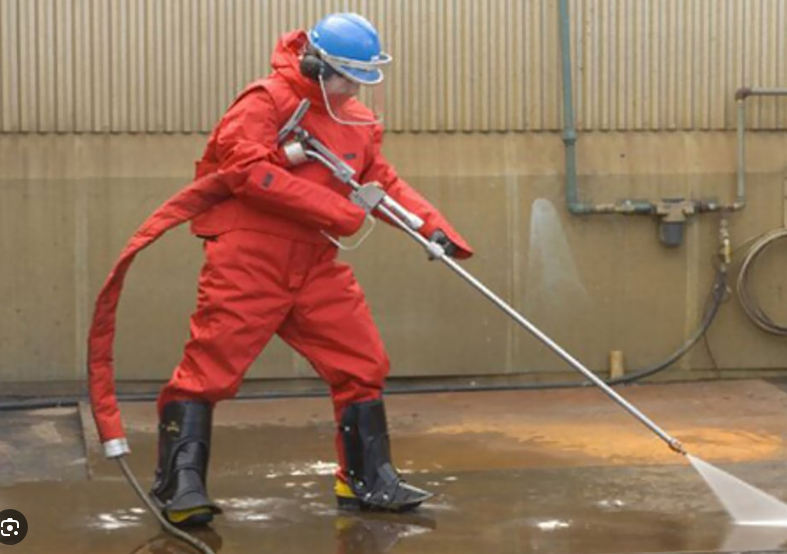

THE TRIGGER MECHANISM MUST NEVER BE LOCKED, WEDGED OR BLOCKED IN THE ON POSITION.

- No person besides the operators shall be within 10 meters of operating Hydro jetting equipment without his permission. The system shall be de-pressured anytime an unauthorized person enters the barricaded area.

- Hand held shot-gunning should not be performed at above 10,000 psi (680 bar) nozzle pressure with a nozzle orifice larger than 1.6mm due to excessive nozzle reaction forces. (due consideration of the body weight of the operator and reaction force must be taken into consideration when using any hand held device).
Back Thrust (Ibf.) = 0.052 x flow rate x

(Flow in GPM, Pressure in Psi; 1 lb. =4.448N)

Note: Reaction force is a combination of Pressure and Flow of the high pressure pump. Back thrust for the Gun Operation should be Less than 250 N.

- The operator shall never direct the lance toward himself or another person at any time.
- The use of a Burst Protection Sleeve where the Ultra high pressure hose joins a hand held device is required. This will offer protection to the operator in the event of a hose failure or leak at the fitting.

- Multiple manual Hydro jetting operations should be separated by at least 6 meters or by an adequate physical barrier.
- When lancing, drain cleaning or pipe cleaning, the lance or hose shall be clearly marked with paints or tapes no closer than 600 mm, from the nozzle to warn the operator of the nozzle location. (Consider the use of a “leader” hose!)

- When flex lancing, drain cleaning or pipe cleaning, the rigid section at the end of the hose should be sufficient length to prevent the nozzle from turning around inside the pipe. The total length of the lance and nozzle shall be larger than the inside diameter of the pipe being cleaned. (Consider the use of a “STINGER” lance!).

- Anti-withdrawal devices must be used for all lancing, pipe cleaning activities.

- Anti-withdrawal devices (Back out preventer & Hose/ Lance catcher must be attached to the pipe or tube bundle which is being cleaned.

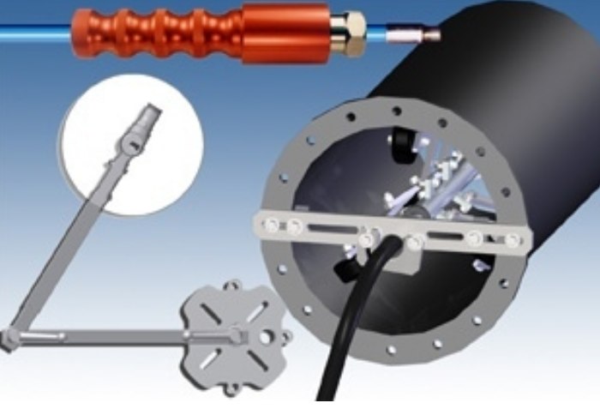

- For Vertical type heat exchanger, vertical hose catcher shall be used.

- When lancing, drain cleaning or pipe cleaning, the nozzle shall be inserted in the tube prior to pressurizing the system and removed from the tube after depressurizing.

- Bolts or other unsecured material shall not be used to mark holes in tube bundles, as they could become projectiles.

- Equipment being cleaned shall not be hand held, but shall be secured to prevent movement.

- High Pressure hoses should be laid in straight lines, and where possible NOT over roadways or suitable hose ramps should be used to protect the hose.

- Hose restraining devices, “whip checks” should be used at all hose joints where practicably possible.

- When hose drops exceed 3 meters, the hose shall be securely tied off to a rigid support to limit the pull due to hose weight.

- Supervisors and Team leaders must understand the implications of pressure losses in hoses and be aware of the potential to increase or over pressure the system when using additional lengths of hose.

- In the event of any water leak, the pumping operation must cease in a safe and controlled way, the system depressurized prior to any repair work being carried out.

- Earthing/Grounding, suitable steps must be taken prevent the build-up of static electricity and grounding (Earthing) is recommended.
Note: when connecting any stainless steel components, e.g. hose end fittings an “Anti-seize”
compound/ grease must be used.

NO WATER JETTING SHALL EVER BE CARRIED OUT IN A LADDER.

JETTING WITHIN A CONFINED SPACE:

Before using HP jetting inside the confined space there are few factors to be considered.
- Assess that jetting within the confined space to be carried out in another method.
- Whether the HP jetter can completely remove from the hazard Example: Use of robot or use of remote tank cleaning head (Torus, Aqua mat, etc.)
If the above factors are not possible then the following steps to be followed.

- Prior to entry a confined space entry procedure/permit to work system should be in place (In other words a safe system of work).
- Adequate emergency arrangements should be in place prior to starting of any work.

- Necessary gas test to be performed before any entry and regular monitoring of the atmosphere may be required during the operation.

- Adequate ventilation and lighting should be provided throughout the job.

- Surface air supplied Breathing air equipment should be used wherever applicable together with appropriate chemical suits/slicker suits. Only Suitably trained operators should be used during such operations.

- Qualified manhole watch/standby man should be present through the confined space entry work.

- The electrical systems (lights etc.) typically of below 25V only should be used during any confined jetting work.

- Adequate communication system is required to enable communication between people inside and outside the confined space and to summon help in an emergency.

- An understanding of how the alarm is raised and who will respond in the case of an emergency/ rescue.

- Only trained/certified operators/standby man should be handling the jetting works inside confined space.

- Provisions for continuous draining or removal of effluents should be carried avoid flooding inside confined space.

- In case of space limitation, use hydraulic or pneumatically operated cleaning heads such as 2D/3D devices for safe cleaning activities. These devices should be used together with a suitable control valve arrangement and should be secured properly to avoid internal equipment damage.

- Initial inspection and assessment of any platforms, trays etc. should be carried out to ensure the integrity structures and platforms to carry-out the cleaning work safely.
- Proper fall arrest devices should be used together with full body rescue harness by the technician/Jetter during confined space work.

- Provision should be made for a rescue harness and lifeline attached to the harness to be connected outside the confined space.

- The technician should be provided with a personal gas meters/alarm to frequently monitor the oxygen/gas levels in the confined space especially while working in equipment in hydrocarbon/chemical service. The technician needs to be trained to use such a monitor.

- Earthing/Grounding, suitable steps must be taken prevent the build-up of static electricity and grounding (Earthing) is recommended.

- When using a high pressure or UHP gun inside a confined space a separate risk assessment should be in place to take into consideration, Barrel length and the use of double trigger gun, and proximity to other persons.

EFFLUENT DISPOSAL

11.1 Consideration shall be given to the Collection and disposal of material removed during cleaning
operations. Special facilities may be required to collect potentially toxic/ hazardous debris wash
water. Such requirements shall be discussed with the Client during job planning stage.

SUPPLEMENTAL PROCEDURE

ASMP Procedures (as applicable)

RELATED DOCUMENTS

- Pre Job Checklist for HPWJ
- Form # - OPS0020804 (Checklist for Visual Inspection-Flexible Lance/Hoses)
- Form # - OPS0030804 (Inert Entry Log Sheet)
- Form # - OPS0040804 (Checklist-HPWJ Cleaning)
- From # - OPS0050804 (Checklist for Visual Testing of HPWJ Hoses)
- Form # - OPS0060804 (Visual Testing of HP Jetting Guns)
- Form # - OPS0070804 (Checklist-Visual Insp. for HP Foot Controls)
- Form # - OPS0080804 (Medical Card for HPWJ Pumps Operator)
- Risk Assessment (Typical)
- Job Safety Analysis (Typical)
- Attachments

ATTACHMENTS

- HPWJ Typical Flow Diagram

CHANGES FROM THE PRECEDING ISSUE

Amendment Record Sheet
Date | Rev. No. | Doc. Section No. | Amended Description: | Amended by: | Approved by:
